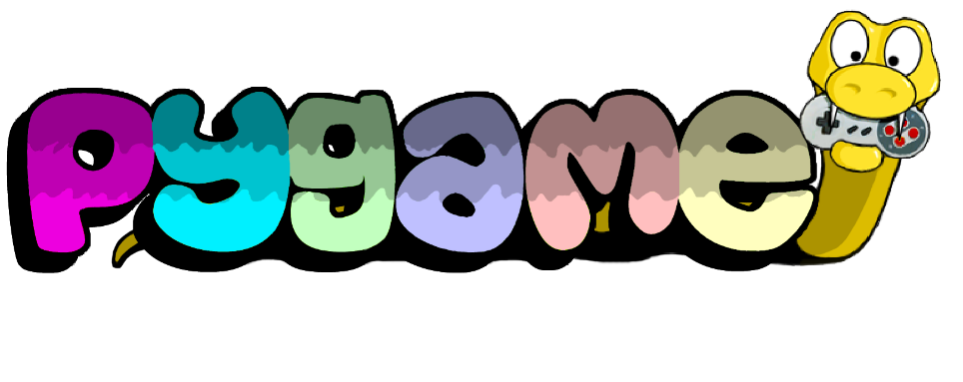

1. **To install Pygame module using the command prompt**









1. **Check if its installed correctly:**



**Project Details:**

For this project you will be using the Pygame library and the “Pygame in 90 minutes – For Beginners” tutorial <https://www.youtube.com/watch?v=jO6qQDNa2UY> to create your first game. You will also have to add the minimum modifications to the game below.

**Pygame modifications**

* A screenshot of a computer

  Description automatically generated with medium confidenceAdd comments to your code where necessary
* Game title should be different on the top left of the window
* Change the window colour to something other than white
* Have unique dimensions for your windows and objects compared to video
* Change all PNG assets to unique items you found online or created
* Use unique button keys for your objects
* Your border should be places horizontally dividing the two moving characters (the video has it placed vertically).
* The bullets should be shot in the vertical direction (up and down since your units will be on the bottom and top of the game.
* Add unique sound effects to your game
* Add your own text to the screen for health + game ending message
* Add any other unique gameplay to your game

**Due Date:**

**April.28/2023**

**Resources**

* A Newbie guide to Pygame: [A Newbie Guide to pygame — pygame v2.1.1 documentation](https://www.pygame.org/docs/tut/newbieguide.html)
* GitHub link to Assets: [GitHub - techwithtim/PygameForBeginners: A simple 2D python game designed to teach you the pygame module.](https://github.com/techwithtim/PygameForBeginners)
* Pygame documentation link: [Pygame Front Page — pygame v2.1.1 documentation](http://www.pygame.org/docs/)
* One website with free png files <https://www.freepngs.com/>